**2018 SANTA CRUZ II ITINERARIES**

**DAY-BY-DAY DESCRIPTIONS**

|  |
| --- |
| TOUR DETAILS |

Tour Name

SANTA CRUZ II Western Galapagos. 5 Days/4 Nights (Thursday to Monday)

Description

A majestic introduction on Dragon Hill sends guests on their way to the western side of the Galapagos archipelago, complete with gorgeous visitor sites on the islands of Isabela and Fernandina. After that, guests will get the chance to get a taste of local island life on Santa Cruz. Finally, the journey concludes with a dose of history, extraordinary wildlife and stunning views at the numerous visitor sites on Floreana Island. This is sure to be a journey to remember!

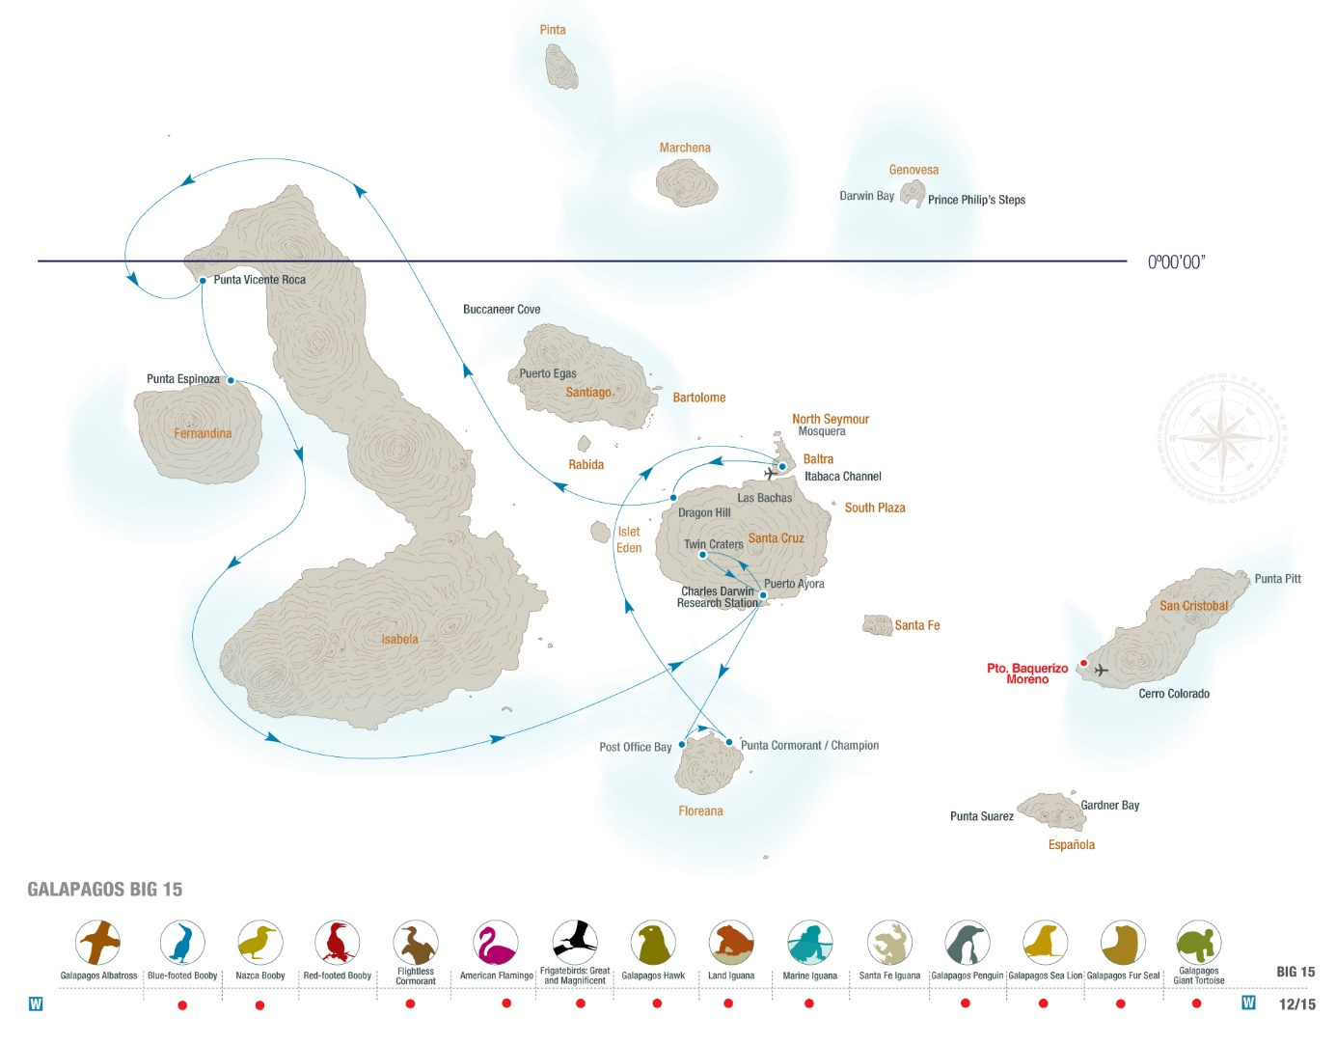

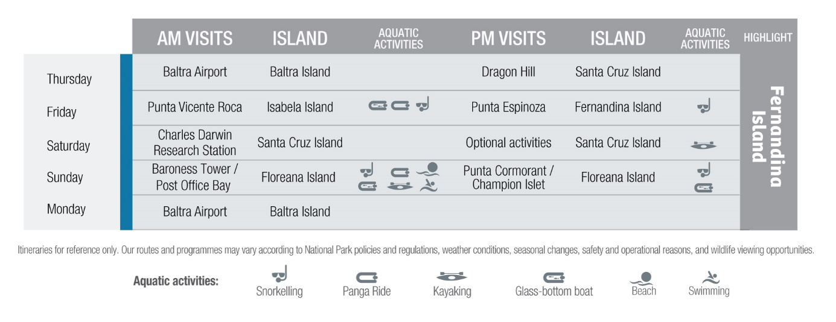**Day 1- Thursday**

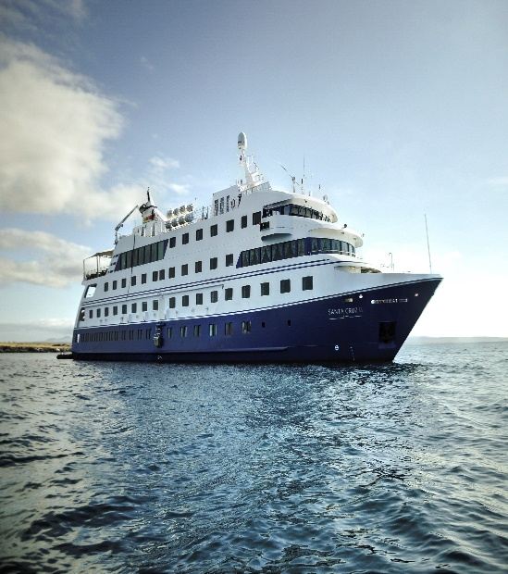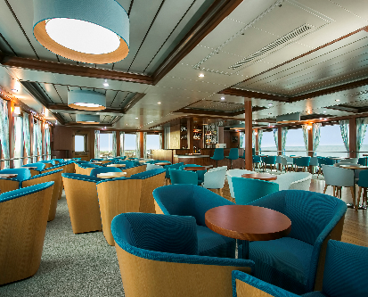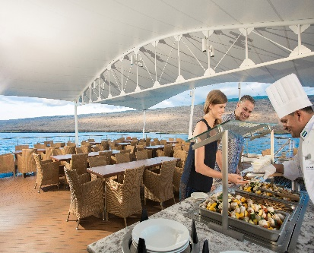

**BALTRA/SANTA CRUZ**

**Baltra Island**

We arrive by plane at Baltra Island and transfer to the dock to board the Santa Cruz II where we receive our welcome introductory briefing, boat drill and lunch.

**Dragon Hill (Santa Cruz Island)**

The north shore of Santa Cruz hosts the fascinating landscapes of Dragon Hill. The first part of our walk passes a brackish-water lagoon frequented by shorebirds, ducks and flamingos, while further inland, the trail offers a beautiful view of the bay and the western islands of the archipelago, as well as the chance to see Galapagos land iguanas.

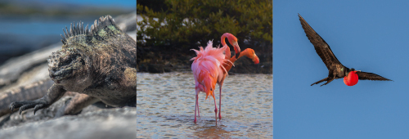

**Day 2- Friday**

**ISABELA/FERNANDINA**

**Punta Vicente Roca (Isabela Island)**

After breakfast, we explore the coast by panga, while our naturalist guide explains the dramatic geology of the area, a nesting place for several Galapagos highlights: flightless cormorants, Galapagos penguins, boobies, etc. Depending on weather conditions, we can snorkel along the cliffs of this area rich in marine life, seasonally-visited by green sea turtles and oceanic sun fish (*Mola Ramsayi*).

**Punta Espinoza (Fernandina Island)**

The afternoon is dedicated to exploring Fernandina, the youngest island of the archipelago, which, having no introduced mammals, boasts a very unique environment with a very high density of marine iguanas, who share their space with sea lions, Sally light-foot crabs, hawks, penguins and the flightless cormorants.

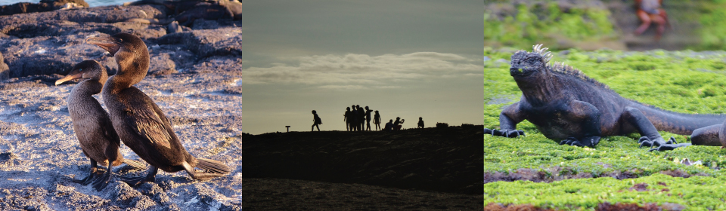

**Day 3- Saturday**

**SANTA CRUZ**

**Puerto Ayora and the Charles Darwin Research Station (Santa Cruz Island)**

In the morning, we disembark (dry landing followed by a brief bus ride) for our visit to the Charles Darwin Research Station’s giant tortoise Breeding Centre within an impressive giant prickly-pear cactus forest, home to many land birds. These are the headquarters of scientific investigation, conservation and the National Park administration. Following our visit, we board our transport to enjoy lunch in the cooler highlands of Santa Cruz Island, a completely different ecosystem.

**Santa Cruz Island**

We have several options available for the afternoon, which can be discussed in advance with your Expedition Leader. Options include beach walks, kayaks, walks along the tortoise reserve, etc. At the end of the afternoon’s activities, we return to Puerto Ayora and embark on the Santa Cruz II.

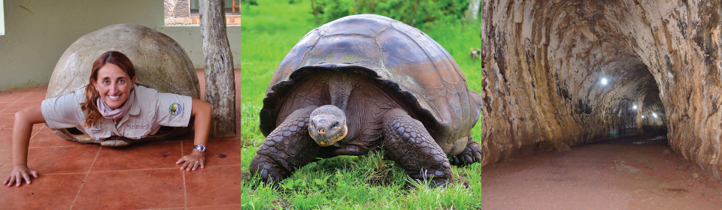

**Day 4- Sunday**

**FLOREANA**

**Baroness Tower - Post Office Bay (Floreana Island)**

After breakfast, panga ride along the maze of channels on Floreana’s north shore can be enjoyed. We follow this visit by continuing to Baroness Cove with its breathtaking views of Floreana. We land at Post Office Bay to visit the historic barrel that has served as a post office in the archipelago for over two centuries and where postcards are traditionally left for guests from other vessels to hand-deliver to their destinations. This is followed by snorkelling along the beach and then we head back on board for lunch.

**Champion Islet– Punta Cormorant (Floreana Island)**

Following lunch, we take the pangas and glass-bottom boat to explore the underwater wonders around Champion Islet – an extinct shield volcano, regarded as one of the best snorkelling spots in the archipelago. From there, it’s onwards to Punta Cormorant. We’ll begin with a wet landing on the olivine-crystal beach followed by an easy walk to a brackish-water lagoon, where bird species such as greater flamingos, pintail ducks, common stilts, herons, sandpipers, and others gather. We continue our walk over to a white-sand beach, where sea turtles emerge from the sea at night to nest (from December to May.

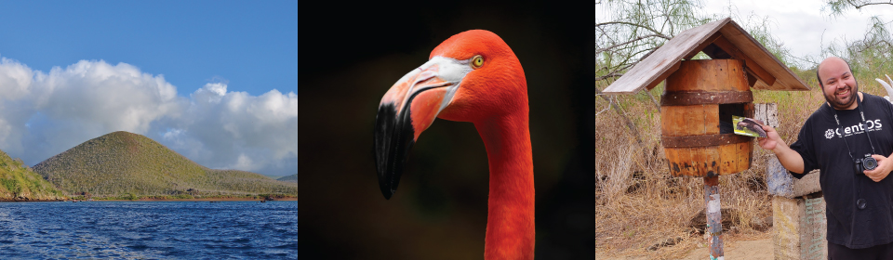

**Day 5- Monday**

**BALTRA**

**Baltra Island**

We disembark at Baltra Island in order to transfer to the airport to take the flight back to the mainland.

**Note**

Please remember that the exact route and programme may vary according to weather and ocean conditions and the wildlife we encounter. It's also subject to change without previous notice due mainly to readjustment of the National Park policies and regulations.

**-Dry landing**: guests step from the panga (inflatable dinghy) onto rocks or a dock.

**-Wet landing:** as the dinghy edges onto a sandy beach, guests step into around 8 inches (20 cm) of water and wade ashore.

**PACKING CHECK LIST**

* 1 small backpack
* Comfortable walking shoes
* Sneakers with rubber soles
* Shorts
* Long pants
* T-shirts
* Long and short sleeved shirts
* Wind breaker
* Bathing suit or a wetsuit for snorkelling in cold months
* Hat or cap
* Sunblock and repellent
* Sunglasses
* Binoculars
* Camera & video recorder
* Any medicine you may be taking
* Book/Notebook

Included

All meals, island sightseeing, naturalists and lecture services, snorkelling gear and transfers.

Not Included

Air tickets to/from Galapagos, Galapagos National Park admission fee (US $100 subject to change without notice), transit Control Card for Galapagos (US$ 20 per person), wet suits, alcoholic and non-alcoholic beverage, tips, gifts, internet* and additional items.

* Due to the Galapagos’ remote location, internet connections are intermittent and low-bandwidth.